0.Datatypes and Size
Thursday, February 27, 2025
11:44 AM

The size of data types in C depends on the system architecture (e.g., 32-bit vs. 64-bit) and the compiler being used.
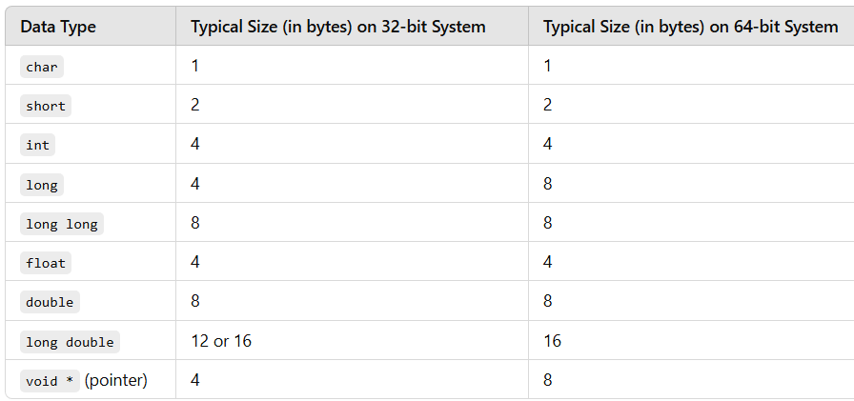
🔹 Pointers (void *, int *, etc.) take 4 bytes on 32-bit and 8 bytes on 64-bit systems.
🔹 long is 4 bytes on 32-bit, but 8 bytes on 64-bit systems (LP64 model).

1.Build stages in a C program
Monday, March 3, 2025
11:46 AM
- Preprocessing stage
- Converts .c -> .i
- It expands macros, includes header files, and removes comments.
- Compilation Stage
- Converts .i->.s
- Translates preprocessed code to assembly language
- It checks for syntax errors and optimizes the code
- Assembly (.s->.o)
- The assembler translates assembly code into machine code(binary format)
- Produces an object file .o containing machine code instructions.
- Linking (.o -> .exe)
- Linker combines object files and resolve function calls(like printf() from stdio.h).
- It links static or dynamic libraries (.so or .a).

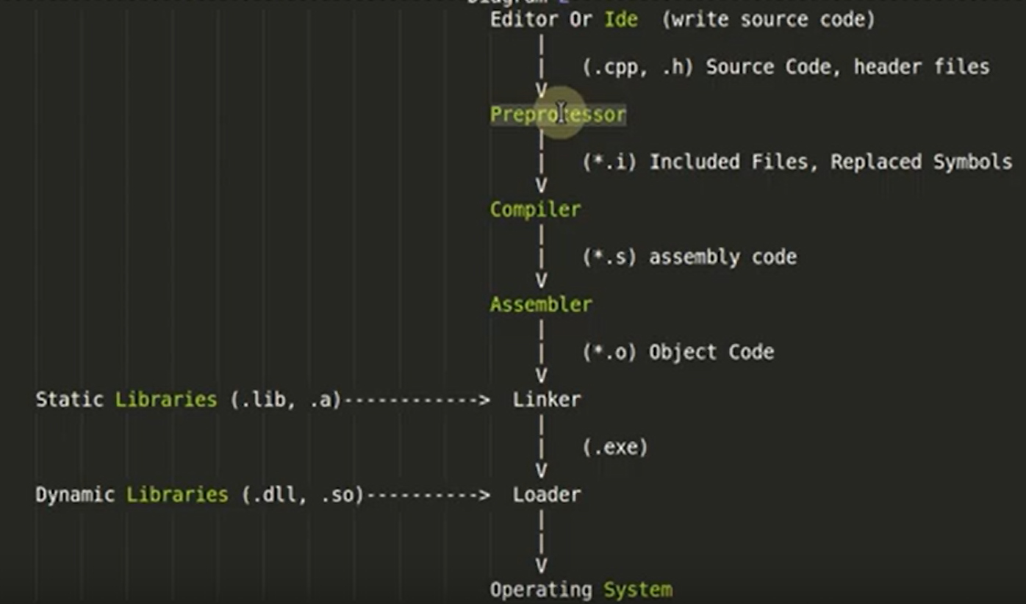

2.Storage classes
Wednesday, February 19, 2025
11:52 AM
- In C ,a storage class defines the scope ,lifetime and visibility of a variable or function

- auto (Automatic Storage Class)
  - Default storage class for local variables inside function
  - Variable is created when the function is called and is destroyed when it exists.
  - Scope :- Block level(local to function)
  - Lifetime:- Until the function executes
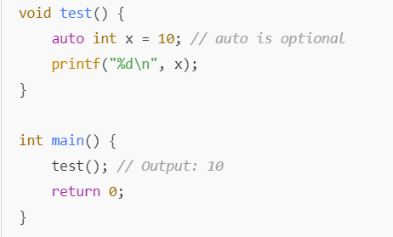
- auto is rarely used explicitly because local variables are auto by default
- register(Register Storage Class)
  - Suggest the compiler to the store the variable in CPU register instead of RAM for faster access.
  - Scope: - Local to function (Block-level)
  - Lifetime:- Until the function executes
  - Note:- Cant use &(address of ) operator because registers don’t have a memory address.
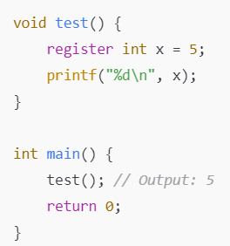
- Modern compilers optimize automatically,so register is rarely used.
- Static(Static Storage Class)
  - Preserves the value of a variable even after function exits.
  - Can be used inside or outside function .
  - Static variables will be initialized only once.
  - Scope:
    - Local Static -> Limited to function/block
    - Global Static -> Limited to the file (not accessible in other files)
  - Lifetime :- Till program termination
Example: Local static variables
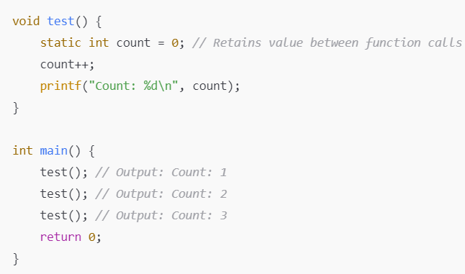
- Static variables are intialized only once and its values are retained across function calls.
Example: Global static Variables
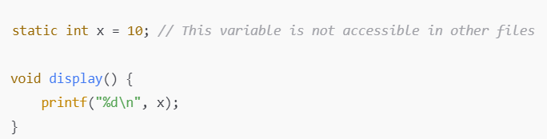

- Used to restrict access to global variables/functions to the same file.
iv. extern(External Storage Class)
- Used to declare a global variable/function that is defined in another file.
- Scope: Global(across multiple files)
- Lifetime: Till program termination
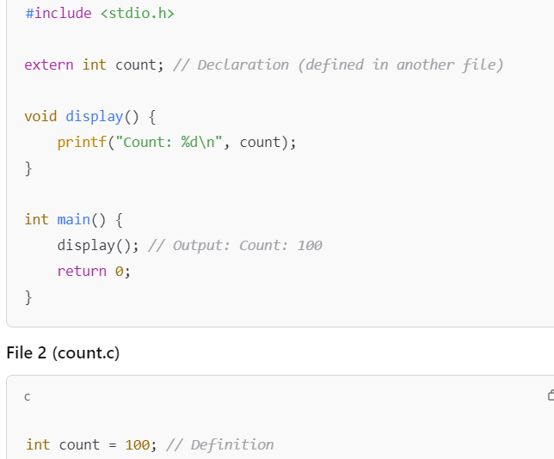
- Useful for sharing global variables across multiple files.
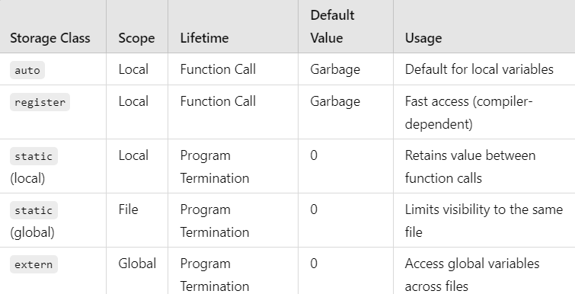

3.Memory layout in a C program
Wednesday, February 19, 2025
3:51 PM
  - When a C program is executed,its memory is divided into 5 main segment
    - Code (Text) Segment
    - Data Segment(Initialized & Uninitialized)
    - Heap
    - Stack
    - BSS Segment (Block Started by Symbol)

  - Code Segment (Text)
    - Stores the compiled machine code(Instruction of the program )
    - Read-only to prevent accidental modifications.
    - e.g :- Function definitions,executable statements
      - .ro data(Read-only Data segment):
        - Stores constant data,such as string literals and const global/static variables.
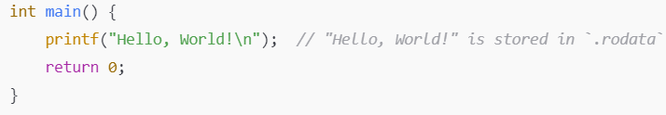
  - .txt:
    - Stores executable instructions of program(machine code)
    - Machine code of foo() is in .txt segment

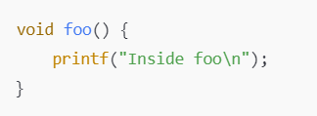

  - Data Segment(Initialized & Uninitialized ) & BSS
    - Stores global & Static Variables
      - .data (Initialized Data segmet) :-
        - Stores global and static variabes that are initialized with a non-zero value.
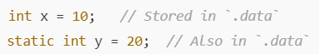
  - Memory is allocated at compile time and remains throughout the program execution .
  - .bss Unitialized Data(BSS Segment):-
    - Stores global and static variables that are uninitalized or initialized to 0.
    - Memory is allocated at runtime,and the values are set to 0 automatically.
    - Uses less space in the executable file since only size info is stored, not actual values.

  - Heap(Dynamic Memory Allocation )
    - Used for dynamically allocated memory (malloc,calloc,new).
    - Memory is allocated at runtime and must be freed(free in C ,delete in C++)
    - Heap segment grows upward in memory.
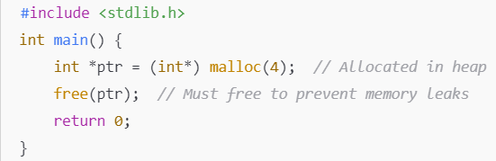
  - Stack Segment
    - Stores function call information,local variables and return address .
    - Grows downward(towards lower memory adresses)
    - Memory is automatically allocated and freed when functions are called/returned.
    - Stack overflow occurs if too much memory is used (e.g., deep recursion)
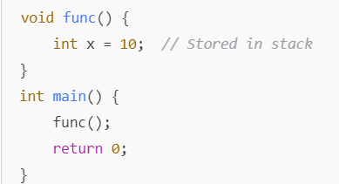

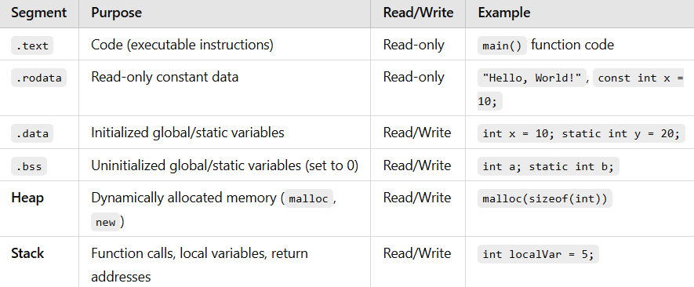

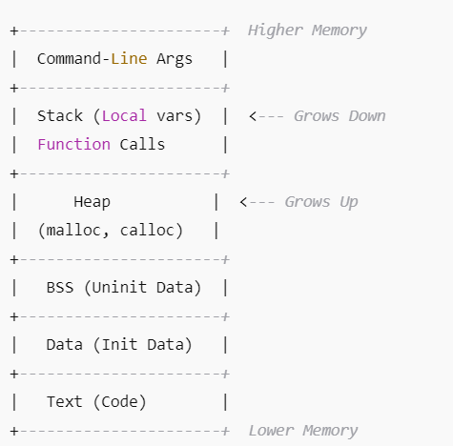

4.Lvalue vs rvalue
Wednesday, February 19, 2025
11:53 AM
  - Lvalue
  - lvalue(locator value) refers to an object that has an address in memory and can appear on both left and right sides of assignment
✅ Can be modified (if not const)
✅ Has a memory location (stored in RAM)
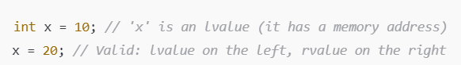
  - Rvalue
rvalue(right value) is a temporary value that does not have a persistant memory location and can appear on the right side of an assignment.
❌ Cannot be assigned a new value
❌ Cannot take the address-of (&) operator
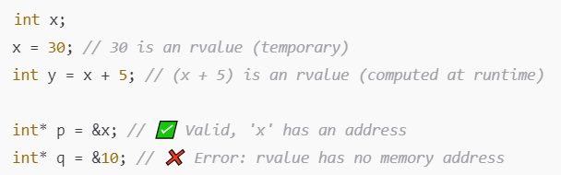
Special Case in C++
  - C++11 : Rvalue Reference(&&)
    - In C++11 ,rvalue references(&&) allow moving temporary values efficiently instead of copying them .
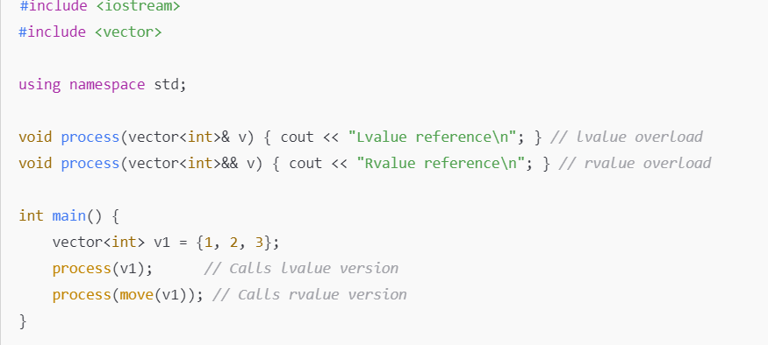

5.Typedef_vs_Macro
Wednesday, February 19, 2025
11:53 AM
- Typedef
  - typedef is used to create an alias for a type.
  - typedef follows type-checking and integrates seamlessly with the compiler.
  - Helps in defining more readable and managable code ,especially for complex datastructures like structs and function pointers
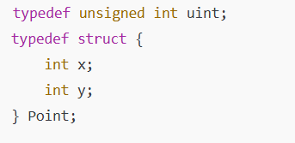
- uint is an alias for unsigned int
- Point is an alias for struct { int x; int y; }.
Advantages:
- Strong type-checking: The compiler enforces type rules.
- Scoping: typedef respects block scope.
- More readable code: Makes complex types easier to use.
ii. #define (MACRO)
- #define is a preprocessor directive that replaces occurences of a token with a specified sequence before compilation
- It does not perform type-checking.
- Used for defining constants,function like macros and sometimes for type aliases
Type Alias using Macro
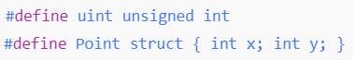

Problem with type aliasing using Macro
1.No type checking :- The preprocessor will replace the text blindly
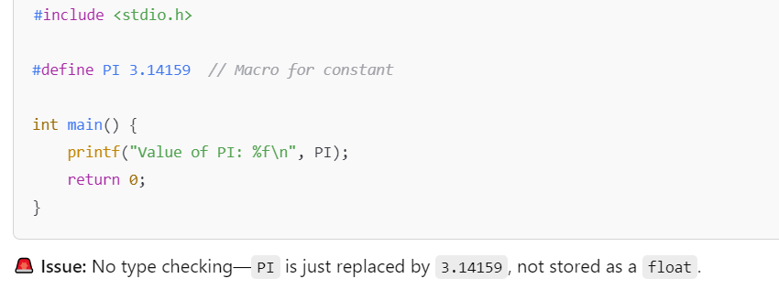
2.No scoping :- Macros are global and can cause unintended conflicts
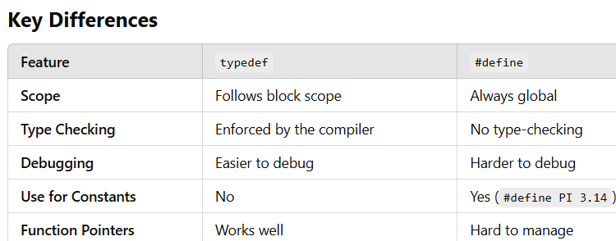

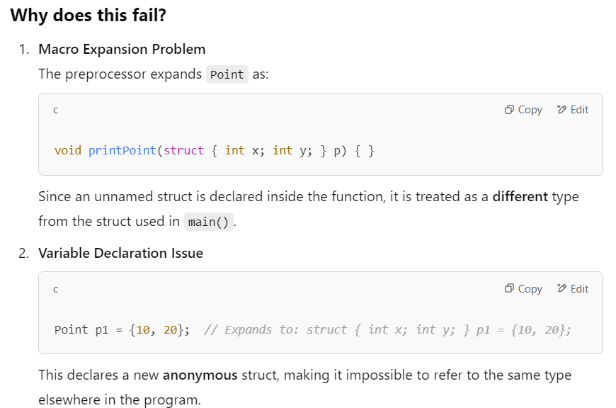

6.Function Pointers
Wednesday, February 19, 2025
11:54 AM
  - Function pointer in C is a pointer that store the address of a function .
  - It allows functions to be called dynamically at runtime
Syntax:
return_type (*pointer_name)(parameter_list);
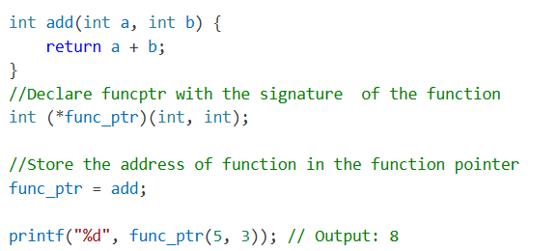
USECASES OF FUNCTION POINTERS
  - Callback Mechanism
  - Used to pass functions as argument to other functions
  - Common in event driven programming and interrupt handling
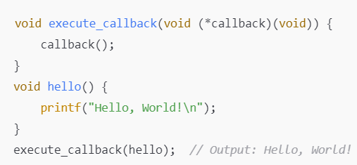
  - Dynamic Function Selection
  - Used for selecting functions at runtime
  - Can be used for choosing different operations in a menu-driven program
  - 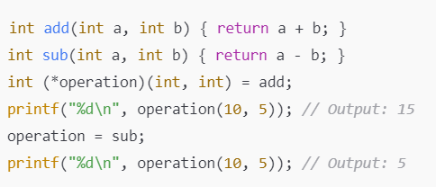
  - Implementing State Machines
  - Used for switching between different states dynamically.
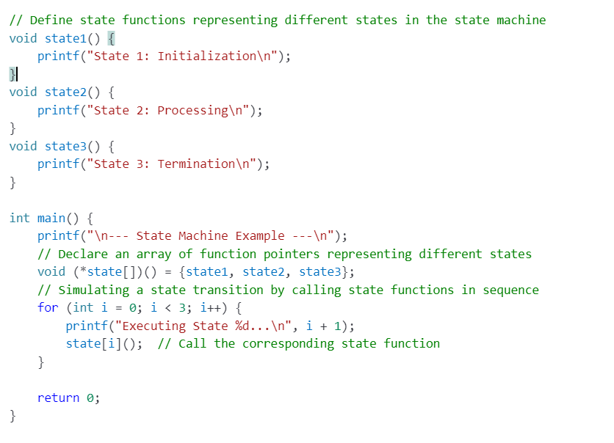
  - Struct With Function Pointer (OOP like behavior)
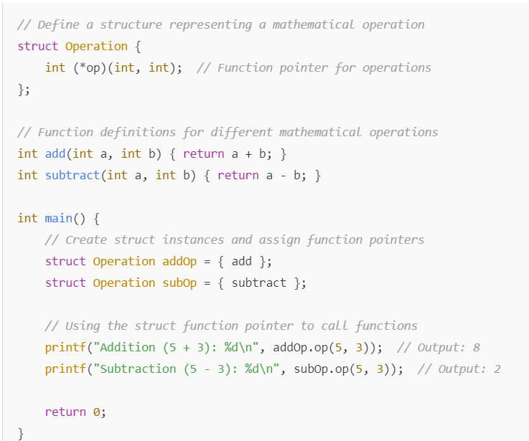

  - Used in Embedded systems and drivers to define the function behaviors dynamically
  - Jump Tables (Reducing if-else/switch cases)
  - Jump tables are an efficient alternative to if-else or switch-case statements,especially when handling menu-driven programs,command execution or event handling in embedded systems
  - Used to implement efficient decision-making instead of long switch-case statements.
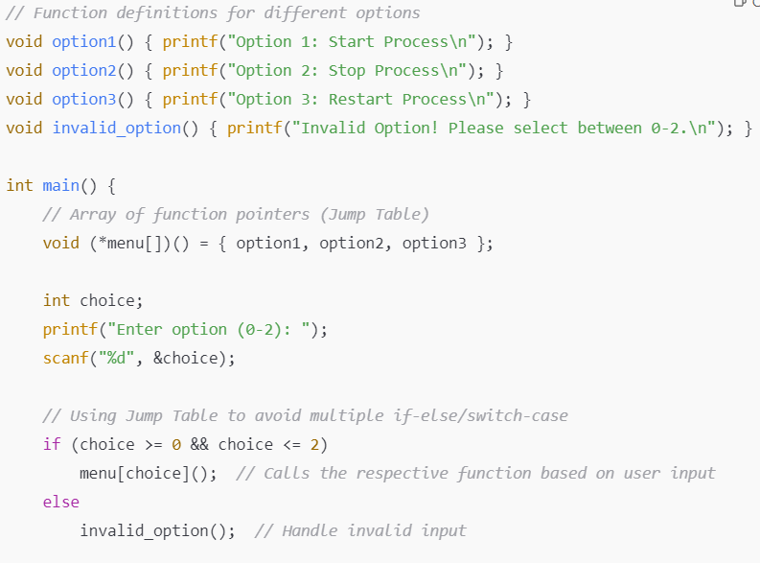
Output:
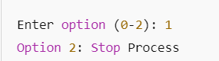

7.String in C vs C++
Thursday, February 27, 2025
8:42 AM
  - C-style String
    - In C,string are represented as character arrays(char arr[] or char*ptr) terminated by a null character .
    - Standard library functions like strcpy(),strcat(),strlen() and strcmp() are used for manipulation .
    - Requires manual memory management for dynamic allocation using malloc() or calloc().
    - 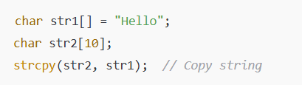
  - Q:Why in C style string assignment is not allowed ?
    - Arrays are fixed in memory
      - In c ,string is declared as character array (char str[10]),its address is fixed and assigning a new string to it is not allowed .
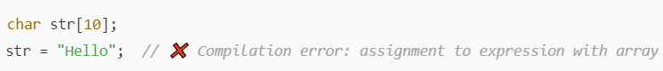
  - String literals are stored in read-only memory :
    - Assigning a string literal directly to an array variable mean modifying the read-only memory .
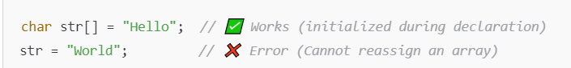
  - Q: Why character pointers can be modified?
    - Pointers can be reassigned,it will point to another char array memory location

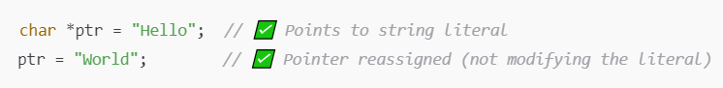

How to Modify C-style String :- Use strcpy() or strncpy()
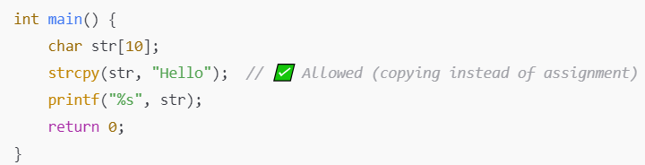

  - C++ Style String
    - In C++ string is a class std::string in the STL.
    - Memory is handled dynamically internally,avoiding manual memory handling.
    - Allows intuitive operations like concatenation (+), comparison (==), and direct assignment (=).
    - Offers built-in member functions like .length(), .append(), .substr(), and operator+ for easy manipulation.
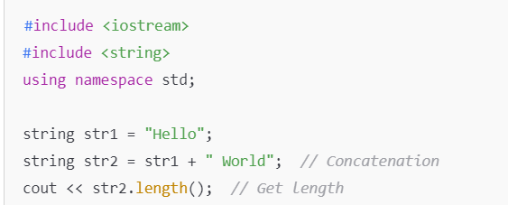

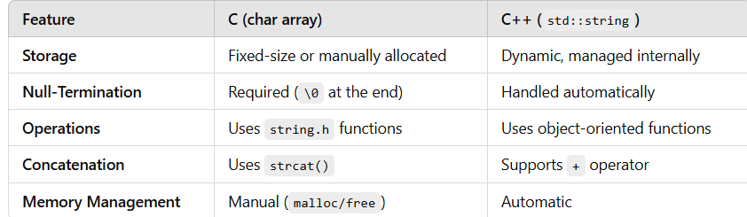
Why is assignment possible in C++ std::string?
In C++, std::string allows assignment using the = operator because it is a class with operator overloading and handles memory dynamically.

8.String literals
Thursday, February 27, 2025
9:13 AM
- A string literal is a sequence of characters enclosed in double quotes" " which represents a constant string in memory .
CHARACTERISTICS OF STRING LITERALS
- Stored in Read-Only Memory
  - String literals are typically stored in read-only memory .
  - Modifying string literal causes undefined behaviour

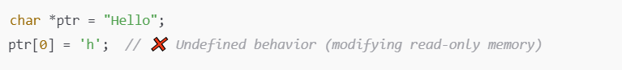
- Automaticall Null-Terminated (\0)
  - String literals always end with a null character \0 making them a valid C-style string
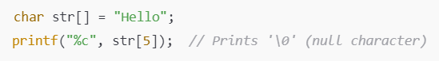
- Pointer vs Array Representation
  - When assign to a pointer (char*) it points to a read-only memory location .
  - When assigned to an array (char array[]) it copies literal into a modifiable memory.
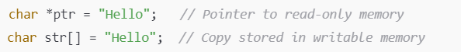
- String Literals in C++ (std::string)
  - In C++, std::string allows direct assignment from string literal.
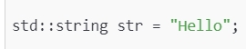

9.Bit packing & unpacking using Struct
Thursday, February 27, 2025
8:42 AM
- Bit packing and bit unpacking are techniques used to efficiently store and retrieve multiple small values with a single larger datatype (e.g uint32_t) by using bitwise operations.

1.BIT PACKING & UNPACKING USING BITWISE OPERATION
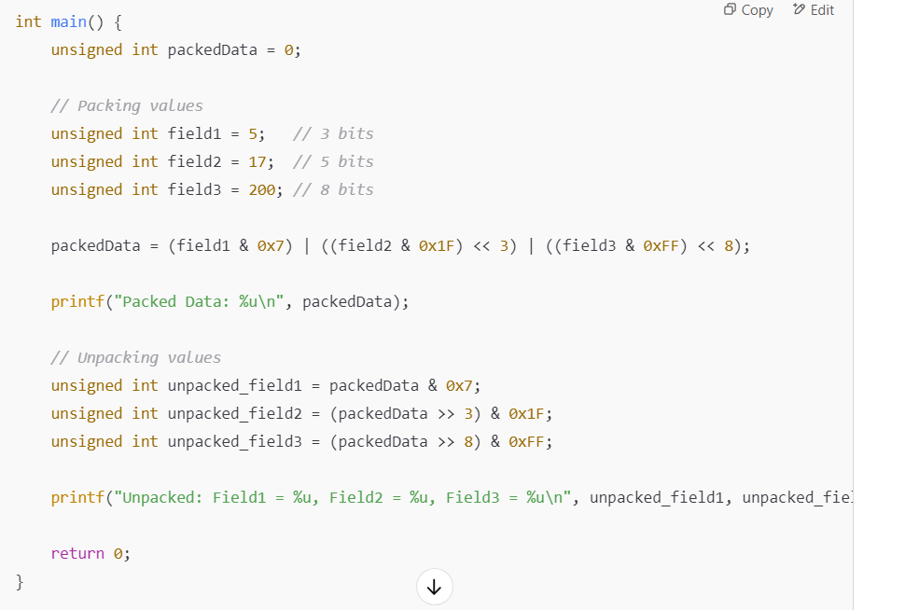
2.BIT PACKING USING STRUCTURE BITFIELDS

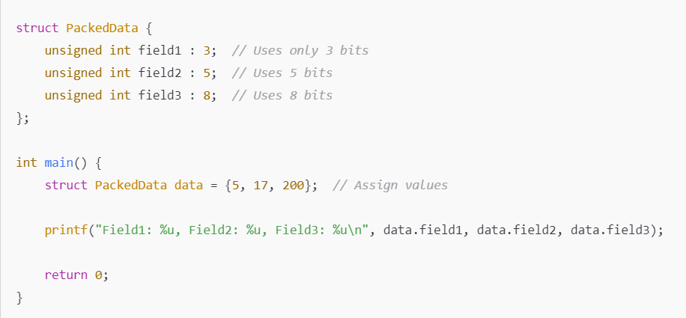

10.Bit Fields
Thursday, February 27, 2025
10:55 AM
- A bit-field is a way to define structure members that occupies only a specific number of bits rather than an entire storage like(int or char)
- Bit Fields helps in memory-efficient storage
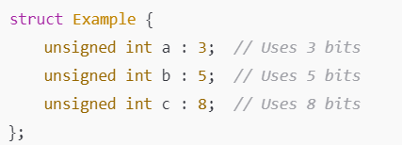
- Only 16 bits i.e 2bytes are needed to store the 3 values instead of (4bytes *3)12bytes->96bits.
ALIGNMENT & PADDING IN BIT_FIELDS
- Memory Alignment
  - Compiler tries to align structure members to memory address that are multiple of their natural size(Usually most compilers are 4 byte aligned).
  - This alignment improves CPU performance by ensuring efficient memory access.
- PADDING
  - The compiler may add padding to meet the alignment requirements.
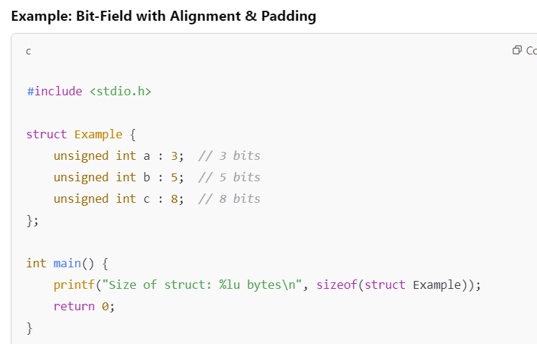

🔹 Expected: 3 + 5 + 8 = 16 bits (2 bytes)
🔹 Actual Output: Likely 4 bytes due to alignment of unsigned int (typically 4 bytes).

How to avoid Padding ?
- Using #pragma pack(1) (GCC & MSVC)

- Using __attribute__((packed)) (GCC & Clang)

11.Const Reference
Friday, March 21, 2025
10:40 AM
- Const reference in C/C++ is a reference to a variable that cannot be modified through reference.
- It provides way to access an object without allowing changes to it,ensuring dataintegrity while avoiding unnecessary copy of data.
Syntax :
const int& ref = variable;
- const keyword ensures that ref cannot modify the variable.
USECASES
- Read-Only Access:- Useful when we want to access a variable without the risk of accidental modification
- Efficient Parameter Passing :- Instead of passing large objects by value(which incurs a copy operation) we can pass them by const reference for efficiency.
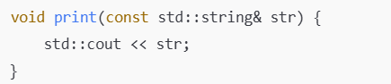

12. Void pointers in C
Friday, March 21, 2025
4:50 PM
- Void pointer in C/C++ is a pointer that can hold the address of any datatype .
- Void pointers can be used when we need to refer to different types dynamically.
- We cannot dereference void pointers directly and need explicit type casting
- e.g malloc & free in C returns and accepts void pointers,allowing allocation and deallocation of memory of any type.
APPLICATION OF VOID POINTERS
- Implementation of Generic Data Structures
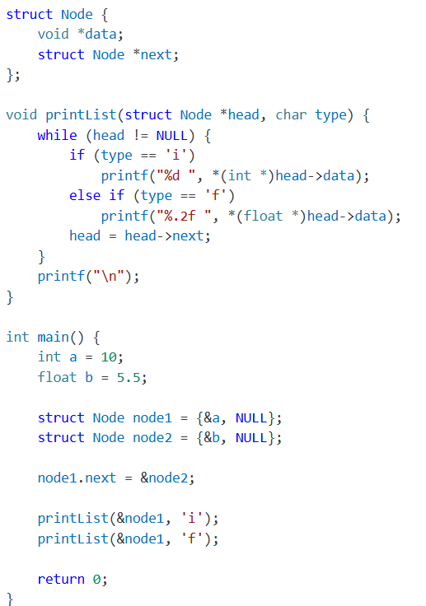
- Datastructures like linkedlists,stacks or queues can use void pointers to store data of any type
- Call_Back and Function pointers
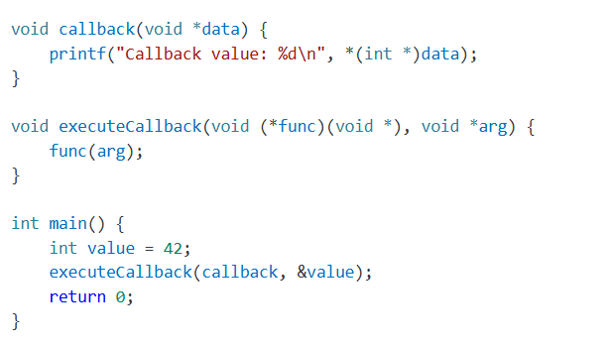
- Callback function :- prints an integer value pointer by void* data.
- ExecuteCallback :- Function pointer (func) matches the signature of callback().
  - Integer value is passed by reference to executeCallback ,which forwards it to callback function .

- Hardware Interaction (Dummy Example)
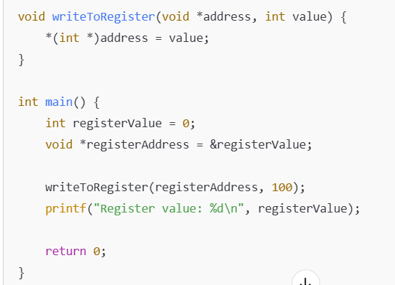

13.Global variables vs Static Variables in Memory
Monday, April 21, 2025
8:43 PM

✅ Global Variables
- Initialized global variables → go to the Data Segment.
- Uninitialized global variables → go to the BSS Segment.
✅ Static Variables (inside functions or at file scope)
- Behave just like globals in terms of memory.
- Initialized static variables → Data Segment.
- Uninitialized static variables → BSS Segment.
They both live for the entire lifetime of the program, regardless of where they’re declared.

14. Malloc in C
Monday, April 21, 2025
8:45 PM
malloc stands for Memory Allocation.
It’s a function in C used to dynamically allocate memory at runtime from the heap.

📦 Syntax:

c
Copy code
void* malloc(size_t size);
- It takes the number of bytes to allocate.
- Returns a pointer to the beginning of the allocated block.
- If memory can’t be allocated, it returns NULL.

15.Malloc in Infinite loop
Monday, April 21, 2025
8:46 PM

If you execute malloc inside an infinite loop without freeing the allocated memory, here’s what happens
🚨 What Happens:
- Memory Leak: Every time malloc runs, it grabs a chunk of memory from the heap.
- Since you never free it, the heap keeps shrinking.
- Eventually, you’ll run out of heap space.

📉 Result:
- malloc will start returning NULL (memory allocation failure).
- If your code doesn’t check for NULL, and still tries to use that pointer:
  - ❌ Segmentation fault / crash
- If the system is under memory pressure:
  - ⚠️ The OS might kill the process (e.g., via OOM killer in Linux).

16.Memory Location of Variables
Friday, July 4, 2025
4:43 PM

🔹 Variables stored in RAM (Random Access Memory)
RAM is used for read-write data, so most variables that change during program execution go here.
1. Stack Segment (RAM)
- Stores: Local variables (non-static), function parameters
- Lifetime: Created on function call, destroyed on return
- Example:
c
CopyEdit
void func() {
int a = 10; // Stored in stack
}
2. Heap Segment (RAM)
- Stores: Dynamically allocated variables
- Lifetime: Until explicitly freed using free() or delete
- Example:
c
CopyEdit
int* p = malloc(sizeof(int)); // p points to heap
3. Data Segment (RAM)
- Stores:
  - Global/static variables that are initialized
  - Divided into .data (initialized) and .bss (uninitialized)
- Example:
c
CopyEdit
int global_var = 5; // .data
static int static_var = 3; // .data
int uninit_var; // .bss

🔹 Variables stored in ROM (Read-Only Memory)
ROM stores read-only and constant data. These values cannot be modified at runtime.
1. Text/Code Segment
- Stores: Function code/instructions
- Example:
c
CopyEdit
void main() {
// The compiled machine code for this function goes into ROM
}
2. RO Data Segment (Read-Only Data)
- Stores: const qualified global/static variables, string literals
- Example:
c
CopyEdit
const int config_value = 42; // Might be in ROM (depending on compiler/linker)
char* str = "Hello"; // String literal in ROM
Note: On some embedded systems, const data is guaranteed to go to ROM (Flash), while on desktops it may still be copied into RAM unless explicitly instructed.

17.Linux system call program
Friday, July 4, 2025
4:44 PM

Linux system call program written in C, which uses the write() and exit() system calls directly using the syscall interface.
✅ Example: Using Linux system calls directly

#include <unistd.h> // for syscall numbers like SYS_write
#include <sys/syscall.h> // for SYS_write, SYS_exit
int main() {
const char *msg = "Hello from system call!\n";
// Call write system call (syscall number: SYS_write)
syscall(SYS_write, 1, msg, 24); // 1 = stdout
// Call exit system call (syscall number: SYS_exit)
syscall(SYS_exit, 0);
return 0; // This line will not be reached
}

18.ISR for toggling an LED
Friday, July 4, 2025
4:47 PM

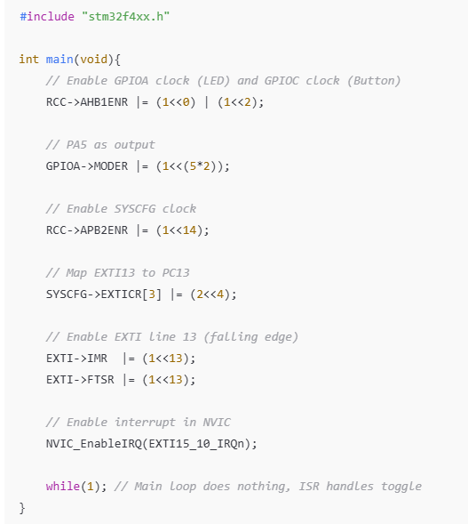

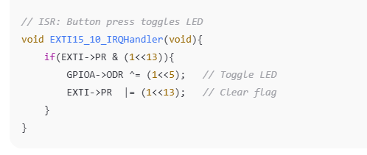

19.Autosar Naming Conventions
Friday, July 4, 2025
4:49 PM

In AUTOSAR (AUTomotive Open System ARchitecture), naming conventions are strictly standardized to improve readability, traceability, and consistency across OEMs and suppliers. The conventions apply to variables, functions, files, macros, etc., and are often detailed in documents like the AUTOSAR C++14 Guidelines, AUTOSAR BSW Module Specs, and MISRA/AUTOSAR coding standards.

✅ 1. General Naming Principles
Element | Convention | Example
Variables | camelCase for locals, PascalCase for global | engineSpeed, BatteryVoltage
Functions | PascalCase | GetEngineStatus()
Macros / Constants | ALL_CAPS_WITH_UNDERSCORES | MAX_SPEED, ENGINE_ON
Types (struct, enum) | PascalCase_T or PascalCaseType | EngineState_T, StatusType
Files | snake_case with .c or .h | can_driver.c, ecu_config.h
Modules | UpperCamelCase or Module Prefix | CanIf, PduR, Det

✅ 2. BSW and RTE Naming Conventions
AUTOSAR has standardized naming for interfaces, ports, signals, etc., especially in RTE and BSW layers.
a. Runnable Naming
- Format: <SwcName>_<RunnableName>
- Example: EngineCtrl_ReadSpeed
b. Port Interface Functions
- Client call: Rte_Call_<Port>_<Operation>
- Example: Rte_Call_DiagnosticPort_ReportError()
- Server runnable: Rte_<Swc>_<Operation>
- Example: Rte_EngineCtrl_ReportError()
c. Sender-Receiver Interfaces
- Read: Rte_Read_<Port>_<DataElement>
- Write: Rte_Write_<Port>_<DataElement>
Example:

c
CopyEdit
Rte_Read_SpeedSensor_Speed(&localSpeed);
Rte_Write_EngineCtrl_Throttle(throttleValue);

✅ 3. BSW Module Naming Examples
Module | Function Naming Format | Example
CanIf | CanIf_<FunctionName> | CanIf_Transmit()
Com | Com_<FunctionName> | Com_SendSignal(), Com_Receive()
Det | Det_ReportError()
NvM | NvM_<FunctionName> | NvM_ReadBlock(), NvM_WriteBlock()

✅ 4. Prefixes and Abbreviations
AUTOSAR uses abbreviations/prefixes to indicate context:
Prefix | Meaning
u8, s16 | Unsigned 8-bit, Signed 16-bit
Ptr | Pointer
Cfg | Configuration
Ch | Channel
Rx, Tx | Receive, Transmit
Swc, Rte, Pdu | Software Component, RTE, Protocol Data Unit

Example:

c
CopyEdit
u8_ChannelId, pTxDataPtr, Rte_Swc_ReadInput()

✅ 5. Configuration and Generated Code
- Configuration structures: Module_ConfigType, Module_Config
  - Example: Can_ConfigType, Can_Config
- Handle IDs: Module_ChannelHandle, Pdu_HandleType

🧠 Tips for Compliance
- Stick to AUTOSAR Layered Architecture for naming (SWC, RTE, BSW).
- Use AUTOSAR XML (ARXML) generated names when integrating with tools.
- Respect naming rules defined in the module-specific specification.

20.Little Endian vs Big Endian
Tuesday, July 8, 2025
8:11 AM
  - In Little Endian,LSB(Least Significant Byte ) will be stored in the lowest memory address

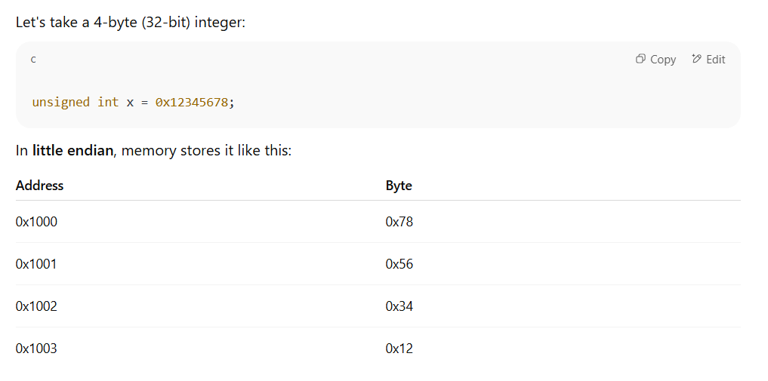

📕 Big Endian
In big endian, the Most Significant Byte (MSB) is stored at the lowest memory address.
Same example:
Address | Byte
0x1000 | 0x12
0x1001 | 0x34
0x1002 | 0x56
0x1003 | 0x78

21.Floating point numbers encoding
Thursday, October 9, 2025
8:05 AM
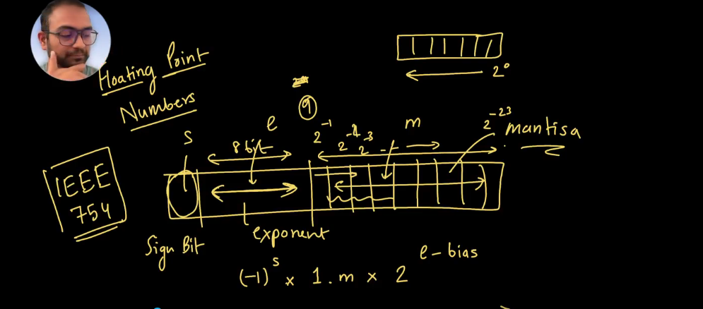
- A floating point number will be divided into 3 parts
  - Sign bit (1bit)
  - Exponent (8bit)
  - Mantissa(23bits) [decreasing order of power of 2 ]
- Any decimal number will be represented in the following format
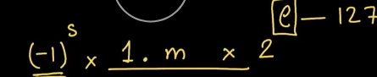

e.g: 2.0 => (-1)^0 x 1.0x2^(e-127) ;we choose e to be 128
s = 0,m=0,e =128

0.5 => (-1)^0 x 1.0 x 2^(e-127) ; e= 126 since 2^-1 = 0.5
s = 0,m=0,e =126
Double Precision floating point
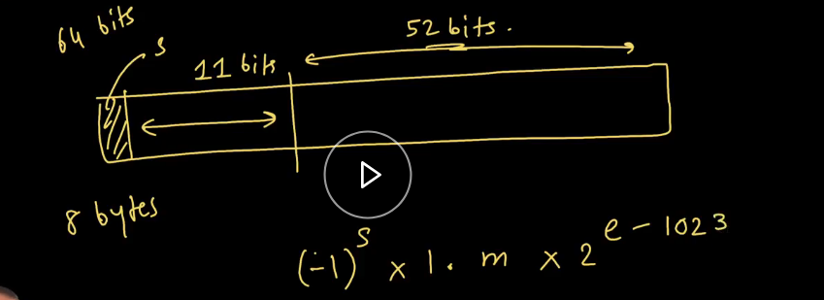

22.STACK VS HEAP
Tuesday, October 21, 2025
8:21 PM

⚙️ Stack
- Fixed-size memory region decided at compile time.
- Used for local variables, function parameters, and return addresses.
- Memory is automatically allocated and freed when a function is called and returned.
- Very fast access since it uses CPU registers and LIFO (Last In, First Out) order.
- Each task/thread in an RTOS has its own stack for isolation.
- Limited in size — large arrays or deep function calls can cause stack overflow.
- No fragmentation since allocation is linear and temporary.
- Preferred in real-time systems due to deterministic behavior.

⚙️ Heap
- Used for dynamic memory allocation when size isn’t known at compile time.
- Memory must be manually allocated (malloc/new) and freed (free/delete).
- Slower access because allocation involves searching free blocks in memory.
- Can lead to memory fragmentation over time, reducing available space.
- If memory is not freed properly, it causes memory leaks.
- Heap is shared among tasks, so synchronization (mutex/lock) may be required.
- Non-deterministic allocation/deallocation time — not ideal for hard real-time applications.

⚖️ Trade-offs
- Stack: Fast, predictable, safe — but limited and inflexible.
- Heap: Flexible and scalable — but slower, non-deterministic, and error-prone.
- In embedded systems, prefer stack wherever possible; use heap only when dynamic data is absolutely necessary.

23.C vs C++
Tuesday, October 21, 2025
8:34 PM

📝 C vs C++ in Embedded Systems: Final Structured Notes
I. C Language: Choose for Efficiency & Predictability
C is the low-level champion, best for resource-constrained environments.
- Resource Footprint: Smallest code size and runtime overhead. Ideal for 8-bit/16-bit MCUs with minimal RAM/Flash.
- Real-Time: Deterministic Performance. Its simplicity ensures highly predictable timing, which is mandatory for safety-critical and hard real-time systems.
- Hardware Control: Excellent for Bare-Metal Control. It's the standard for writing Device Drivers and is used in nearly all vendor HALs.
- Ecosystem: Universal Support ensures compatibility across all compilers and niche architectures.

II. C++ Language: Choose for Complexity & Modularity
C++ is the scalability tool, best for larger, more complex systems.
- Modularity: Enables Scalability and better management of large projects on 32-bit MCUs (RTOS/Embedded Linux) using OOP (Classes, Encapsulation).
- Safety & Robustness: Implements RAII (Resource Acquisition Is Initialization) to ensure automatic, safe release of resources (locks, memory), making code more reliable.
- Type Checking: Offers Stronger Type Checking, which catches more errors at compile-time, saving debugging time later.
- Abstraction: Features like references and constexpr are Zero-Cost Abstractions that make code cleaner and more expressive with minimal runtime penalty.

III. C++ Trade-Offs: How to Use C++ Safely
You must be disciplined to avoid C++ overhead.
- Dynamic Memory (new/delete):
  - Risk: Non-deterministic latency and Heap Fragmentation.
  - Best Practice: AVOID in real-time code. Use static allocation or custom memory pools.
- Exceptions & RTTI:
  - Risk: Massive Code Bloat and unpredictable flow.
  - Best Practice: DISABLE these features via compiler flags.
- Virtual Functions:
  - Risk: Small V-table overhead.
  - Best Practice: Use sparingly, only where abstraction (polymorphism) is necessary, such as in clean HALs.

24.Static vs Dynamic Allocation and Trade offs
Tuesday, October 21, 2025
8:43 PM

Static Allocation (Stack and Data Sections) 🧱
  - Static allocation refers to memory that is allocated at compile-time or upon function entry (stack). The size is fixed and known before the program runs.
Advantages (Trade-offs in favor of Static)
  - Predictability: Allocation and deallocation are instant and completely deterministic. This is critical for real-time systems.
  - Speed: Access is extremely fast since addresses are direct offsets from the base (stack pointer or data section start). No search or management overhead.
  - No Fragmentation: Since memory is never broken up into non-contiguous blocks, there is no risk of heap fragmentation.
  - Simplicity: No need for complex heap management, error checking for allocation failure, or garbage collection.
Disadvantages (Trade-offs against Static)
  - Fixed Size: The array or structure size is fixed at compile time. You cannot adapt to varying inputs or data loads.
  - Limited Scope (Stack): Stack memory is automatically freed when the function exits, making it unsuitable for data that must persist across multiple function calls.
  - Stack Overflow Risk: Deep or recursive functions, or large local variables, can lead to a stack overflow if the stack space is too small.
Dynamic Allocation (Heap) 🔄
  - Dynamic allocation uses the Heap (a large pool of memory) and occurs at runtime (e.g., using malloc/calloc in C or new/delete in C++). The size can be determined during execution.
Advantages (Trade-offs in favor of Dynamic)
  - Flexibility: Allows you to manage data structures (like lists, trees, or buffers) whose size is unknown until the program is running.
  - Memory Efficiency: Memory is only used exactly when needed and released when no longer required, avoiding over-reserving large blocks statically.
  - Persistence: Allocated memory persists until explicitly freed, regardless of function scope.
Disadvantages (Trade-offs against Dynamic)
  - Non-Determinism: Allocation time is unpredictable as the system searches the heap for a block of the required size. This is a major issue for hard real-time systems.
  - Fragmentation: Frequent allocation and deallocation can break the heap into many small, unusable chunks, leading to heap fragmentation.
  - Overhead: Requires a more complex memory manager, consuming a small amount of extra time and memory.

25.Memory Leak /Fragmentation problem
Tuesday, October 21, 2025
8:49 PM

- Your firmware frequently allocates and frees different-sized blocks:
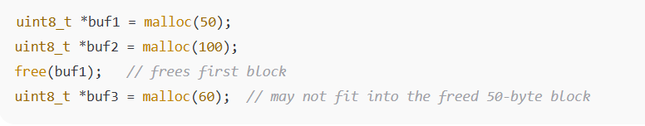

Problem:
- Even if the total free memory is enough, the heap may be fragmented into smaller chunks. Large allocations fail even though enough memory exists overall.

Fragmentation Fix:
- Use fixed-size memory pools instead of repeated malloc/free.
- Pre-allocate buffers for all expected tasks.
- Avoid frequent dynamic allocation in real-time paths.
- Example (using FreeRTOS memory pool):

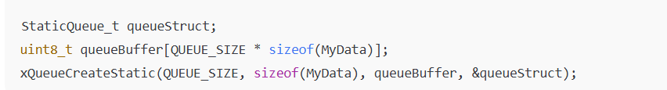

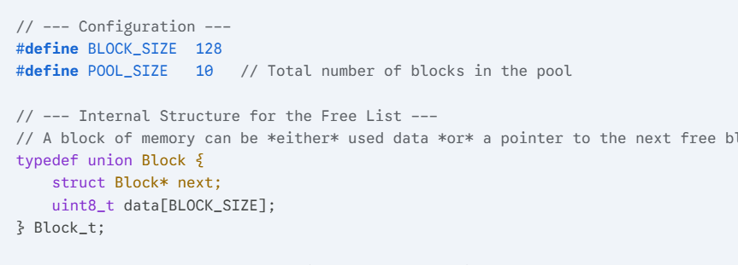
How Mempools Work
The core idea is to substitute the unpredictable heap manager with a simple, deterministic manager for blocks of a single size.
- Pre-allocation: A large, contiguous array (the pool) is allocated statically at startup.
- Fixed-Size Blocks: This array is divided into many small blocks, all of the same size.
- Linked List Management: The memory manager maintains a singly-linked list of all available (free) blocks.
- Allocation: To allocate memory, the system simply pops the first block off the free list. This is an $O(1)$ operation (constant time).
- Deallocation: To free memory, the block is simply pushed back onto the front of the free list. This is also an $O(1)$ operation.

26.Measure time between GPIO Interrupts
Tuesday, October 21, 2025
9:10 PM

The user is asking how to measure the time duration between two external events using common microcontroller peripherals, specifically GPIO Interrupts and a Timer.
The technique is called Input Capture (or sometimes Pulse Width Measurement) and relies on the Timer peripheral being controlled by the GPIO signal.
⏱️ Measuring Time Between Two GPIO Interrupts
To accurately measure the time between two external events (Event 1 and Event 2) triggered by changes on two separate GPIO pins, you use one of the microcontroller's Timer peripherals in Input Capture mode, often linked to the GPIO interrupts.
The Standard Implementation (Input Capture)
The most precise way involves using a single, high-resolution Timer/Counter module.
1. Setup Phase
  - Configure Timer:
  - Set the Timer to run continuously in Up-counting mode at a known, high clock frequency (e.g., 1MHz for 1μs resolution).
  - Initialize the Timer count register to zero.
  - Configure GPIO & Interrupts:
  - Configure GPIO Pin 1 (Event 1) and GPIO Pin 2 (Event 2) as external interrupts (e.g., triggering on a rising edge).
  - Enable the interrupts for both pins.
2. Measurement Logic
The firmware logic tracks the time stamps captured by the Timer.
Step | Event & Action | Result
Start (Event 1) | GPIO 1 Interrupt fires (e.g., Pin 1 goes High). | Capture T1: Read the current value of the Timer's Counter Register and store it in a variable, T1​.
End (Event 2) | GPIO 2 Interrupt fires (e.g., Pin 2 goes High). | Capture T2: Read the current value of the Timer's Counter Register and store it in a variable, T2​.
Calculation | The main application code or a third function executes the math. | Duration: Calculate the difference: Duration = T2​−T1​.

From <https://gemini.google.com/app/45b767969efbf03b>

The user is asking how to measure the time duration between two external events using common microcontroller peripherals, specifically GPIO Interrupts and a Timer.
The technique is called Input Capture (or sometimes Pulse Width Measurement) and relies on the Timer peripheral being controlled by the GPIO signal.
⏱️ Measuring Time Between Two GPIO Interrupts
To accurately measure the time between two external events (Event 1 and Event 2) triggered by changes on two separate GPIO pins, you use one of the microcontroller's Timer peripherals in Input Capture mode, often linked to the GPIO interrupts.
The Standard Implementation (Input Capture)
The most precise way involves using a single, high-resolution Timer/Counter module.
1. Setup Phase
  - Configure Timer:
  - Set the Timer to run continuously in Up-counting mode at a known, high clock frequency (e.g., 1MHz for 1μs resolution).
  - Initialize the Timer count register to zero.
  - Configure GPIO & Interrupts:
  - Configure GPIO Pin 1 (Event 1) and GPIO Pin 2 (Event 2) as external interrupts (e.g., triggering on a rising edge).
  - Enable the interrupts for both pins.
2. Measurement Logic
The firmware logic tracks the time stamps captured by the Timer.
Step | Event & Action | Result
Start (Event 1) | GPIO 1 Interrupt fires (e.g., Pin 1 goes High). | Capture T1: Read the current value of the Timer's Counter Register and store it in a variable, T1​.
End (Event 2) | GPIO 2 Interrupt fires (e.g., Pin 2 goes High). | Capture T2: Read the current value of the Timer's Counter Register and store it in a variable, T2​.
Calculation | The main application code or a third function executes the math. | Duration: Calculate the difference: Duration = T2​−T1​.
Handling Rollover
A critical consideration is Timer Rollover. Since the Timer register (e.g., a 16-bit or 32-bit counter) will eventually hit its maximum value and reset to zero, the calculation must account for this:
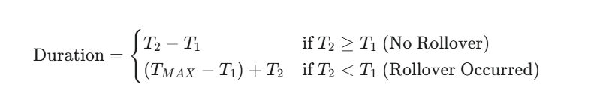

27.SPI vs I2C vs UART
Wednesday, October 22, 2025
6:49 AM

Feature | I²C (Inter-Integrated Circuit) | SPI (Serial Peripheral Interface) | UART (Universal Asynchronous Receiver-Transmitter)
Type | Synchronous, multi-master, multi-slave | Synchronous, single master-multiple slaves | Asynchronous, point-to-point
Lines Required | 2 (SCL, SDA) | 4 (MOSI, MISO, SCLK, SS) | 2 (TX, RX)
Clock Signal | Yes (SCL line) | Yes (SCLK line) | No (asynchronous)
Communication | Half-duplex | Full-duplex | Full-duplex
Speed | Standard: 100 kHz, Fast: 400 kHz, Fast+ 1 MHz, High-speed 3.4 MHz | Typically up to 10 MHz (some devices > 50 MHz) | Common: 9600 – 115200 bps (depends on baud rate)
Topology | Multi-master, multi-slave (addressed) | Single master, multiple slaves (via chip select) | Only 1-to-1 device communication
Hardware Lines | Shared bus | Dedicated lines per slave (or demuxed SS) | Dedicated RX/TX per pair
Error Checking | ACK/NACK bits | None (can be added at protocol layer) | Parity, start/stop bits
Flow Control | Handled by protocol | Controlled by chip-select | Hardware/software (RTS/CTS or XON/XOFF)

🔹 2. How They Work
🧩 I²C
- Master sends START condition → Slave address → Read/Write bit → Data → ACK/NACK → STOP.
- Every device has a unique 7-bit or 10-bit address.
- Pull-up resistors required on SDA and SCL lines.
- Supports multiple masters on the same bus.
- Common in sensors, EEPROMs, RTCs, etc.
👉 Example: Reading temperature from an I²C sensor (like LM75, MPU6050).

⚙️ SPI
- Master generates clock and selects a slave via Chip Select (CS).
- Data simultaneously shifts out on MOSI and in on MISO.
- Each clock cycle transfers one bit both ways (full duplex).
- Fastest of the three, but requires more pins.
👉 Example: Communicating with SD cards, displays, flash memory, ADCs.

🔌 UART
- Serial data transfer using TX/RX.
- No clock line → both devices must agree on baud rate.
- Framing: Start bit → Data bits → Optional parity → Stop bit(s).
- Common for debug ports, GPS modules, Bluetooth (HC-05), etc.
👉 Example: Debugging firmware via serial console.

Interrupts
Tuesday, October 21, 2025
8:12 PM

- An interrupt is an asynchronous hardware or software event that temporarily halts normal CPU execution so an Interrupt Service Routine (ISR) can run to handle the event (timer tick, GPIO change, peripheral ready, fault, software trap).

INTERRUPT vs POLLING

- Without interrupts, you would have to keep checking (polling) every peripheral — wasting CPU time.
- Interrupts make the system react fast and save power by only acting when needed.
Polling | Interrupt
CPU checks repeatedly | CPU reacts only when event occurs
Slow, CPU busy | Fast, CPU efficient
Simple for few events | Better for multiple peripherals
🧩 3. How Interrupts Work in STM32
- A peripheral (like a timer, UART, or GPIO) detects an event.
- It sets a flag and requests an interrupt through the NVIC (Nested Vectored Interrupt Controller).
- The CPU pauses the current task, saves context, and jumps to the ISR.
- Inside the ISR, you handle the event (read data, clear flag, etc.).
- The CPU returns to the main program.

⚙️ 4. NVIC – Nested Vectored Interrupt Controller
The NVIC is a hardware block inside STM32 that:
- Manages all interrupts.
- Allows priorities (decides which interrupt should run first).
- Supports nesting (higher priority interrupt can preempt a lower one).

Toggle an LED using Interrupts
Tuesday, October 21, 2025
8:18 PM

Inter Process Communication
Tuesday, March 18, 2025
6:18 PM
IPC (Inter-Process Communication) refers to the mechanisms that allow processes to communicate and synchronize with each other.
- Since processes run in separate memory spaces, IPC enables them to share data and coordinate their execution.
Types of IPC:
- Pipes – Allows data flow in one direction(half duplex) between two related/unrelated processes.
  - Communication can be within one process or between child and parent process.
- FIFOs (Named Pipes) – Similar to pipes but can be used between unrelated processes and data can flow in both directions(full duplex).
- Message Queues – Allows processes to send and receive messages in a structured format.
  - Process will communicate with each other by posting a message and retreiving it out of a queue.
- Shared Memory – Enables multiple processes to access the same memory space for faster communication.
- Semaphores – Used to manage access to shared resources and prevent race conditions.
- Sockets – Allows communication between processes over a network or between different machines.
- Signals – Communication between multiple processes by way of signalling
  - Source process will send a signal and destination process will handle accordingly .
Use Cases:
- Data sharing between processes.
- Synchronization to avoid race conditions.
- Event notification.
- Remote procedure calls (RPC).

Embedded Bit manipulation
Sunday, September 14, 2025
1:40 PM

  - Count number of set bits (population count / Hamming weight).
  - Kernighan’s algorithm.
  - Lookup table method.
  - Find parity (even or odd number of 1s in binary).
  - Rotate bits (circular shift left/right).
  - Multiply and divide by powers of 2 using shifts.
  - Efficient absolute value using bit manipulation.
  - Fast min/max without branching (using XOR/AND).
  - Check endianness using union. (slightly different from your endian program).

🔹 System / Embedded-Oriented
  - Extract sign, exponent, and mantissa from a floating-point number (IEEE 754).
  - Bit masking for register operations
  - Example: Enable/Disable specific peripheral bits.
  - Pack multiple sensor values into a 32-bit variable.
  - CRC calculation (XOR-based).
  - Gray code conversion (Binary ↔ Gray).
  - Implement a circular buffer index wrap using bitmask (if buffer size is power of 2).

